
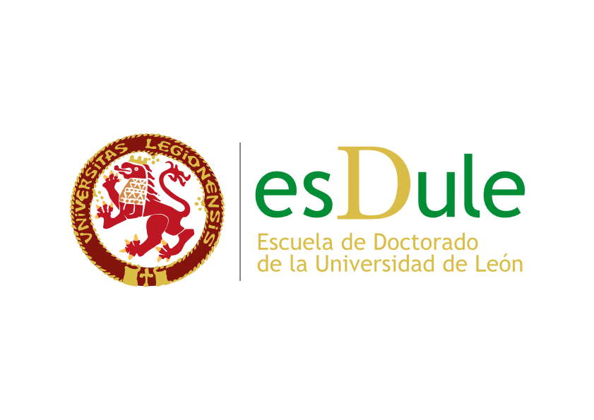

APPLICATION FOR A DUPLICATE COPY OF THE EUROPEAN DIPLOMA SUPPLEMENT

Mr/Ms ……………………………………………………………………………………………….…...........................….
from ……………………………………………………………………..., Province ……….…………...………..….…….,
born in …………………………………………………………………………..…, Gender ……..…..…..............………,
Nationality ……………………………………………………, Country of birth ………………….....………….…………,
ID card/passport no. ….………………………..………., Date of issue ………………………………...………………..,
Permanent address ………………………………………………………………… Postcode ..…….……….……...…...,
Town ………………………, Telephone ………………………., Email address ..……………………..……………….

DECLARES:

- that s/he wishes to obtain a duplicate of the European Supplement to the PhD Degree from the University of León..

- that s/he has paid the amount of the official current fee for the issuance of the duplicate of the European Supplement to the PhD degree, as certified by the attached bank document,

AND REQUESTS: the above-mentioned European Supplement to the PhD degree by the University of León be issued.
Once this document has been issued and in order to collect it, the applicant declares that s/he wishes to use one of the following options (mark the appropriate option with an x):

□ pick it up in person at the Degrees Unit of the University of León. .

□ pick it up in person, having paid the official current fee established for each type of delivery service, at:

- The regional government of ……………………..…………………………… (Spain).
- The Embassy or Consulate of ………………………………………………………..……….....……. ……………………………………………………………………………………...(European countries).
- The Embassy or Consulate of …………………………………………………………………………..
………………………………………………………………………………………...(rest of the world).

In any of the above cases, in order to collect the European Supplement to the Doctorate Degree, a valid ID card or equivalent document must be presented.

León, date; ………………………………… [YYYY-MM-DD]
(Applicant’s signature)

In the event that there is more than one Consulate in the country to which you wish it to be sent, the one to which it is to be delivered must be specified: _______________________________________________

RECTOR OF THE UNIVERSITY OF LEÓN

It may be collected by a person other than the concerned party, regardless of the option chosen, provided that this person is duly authorised by a power of attorney. In this case, both the interested party and the proxy must prove their identity with a valid ID card or equivalent document. LINK TO DATA PROTECTION INFORMATION

